reynolds9.jpg (640×827) (w6rec.com)
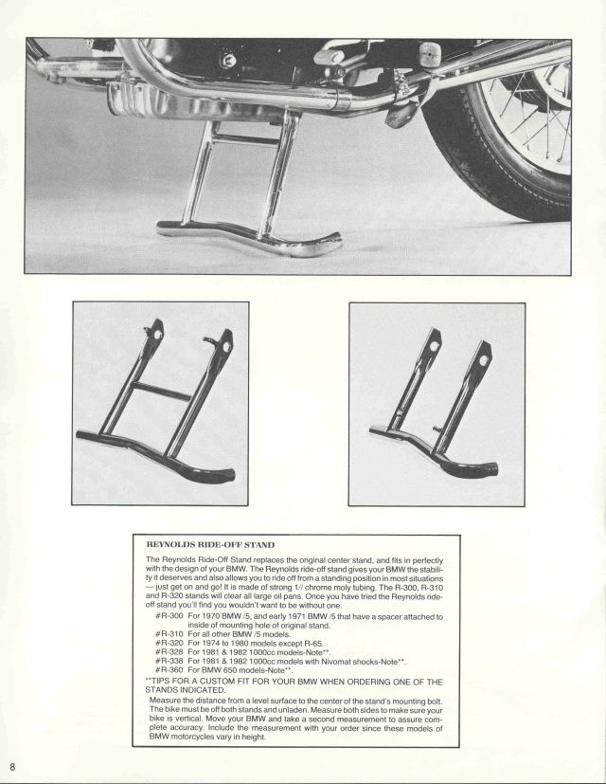

The model number is normally printed above the pivot, on one side, on the outside
